M2 Progress Report — Heterogeneous OS Benchmarking on the Arduino UNO Q

1. Project summary
We test whether a 10 ms control loop keeps its deadlines under heavy Linux load in three OS setups on one Arduino UNO Q. The board pairs a Qualcomm QRB2210 (4× Cortex-A53, Debian 13 Linux) with an STM32U585 (Cortex-M33 at 160 MHz, Zephyr RTOS). The test workload is a Prescriptive Maintenance pipeline: CWRU bearing vibration frames → 1024-point FFT → motor speed setpoint.
- Config A: the 10 ms thread on Linux under the default CFS scheduler.
- Config B: the same thread under SCHED_FIFO priority 90 with mlockall.
- Config C: the 10 ms loop on the Zephyr MCU, while Linux runs the analytics and sends setpoints over the inter-processor link (IPC).
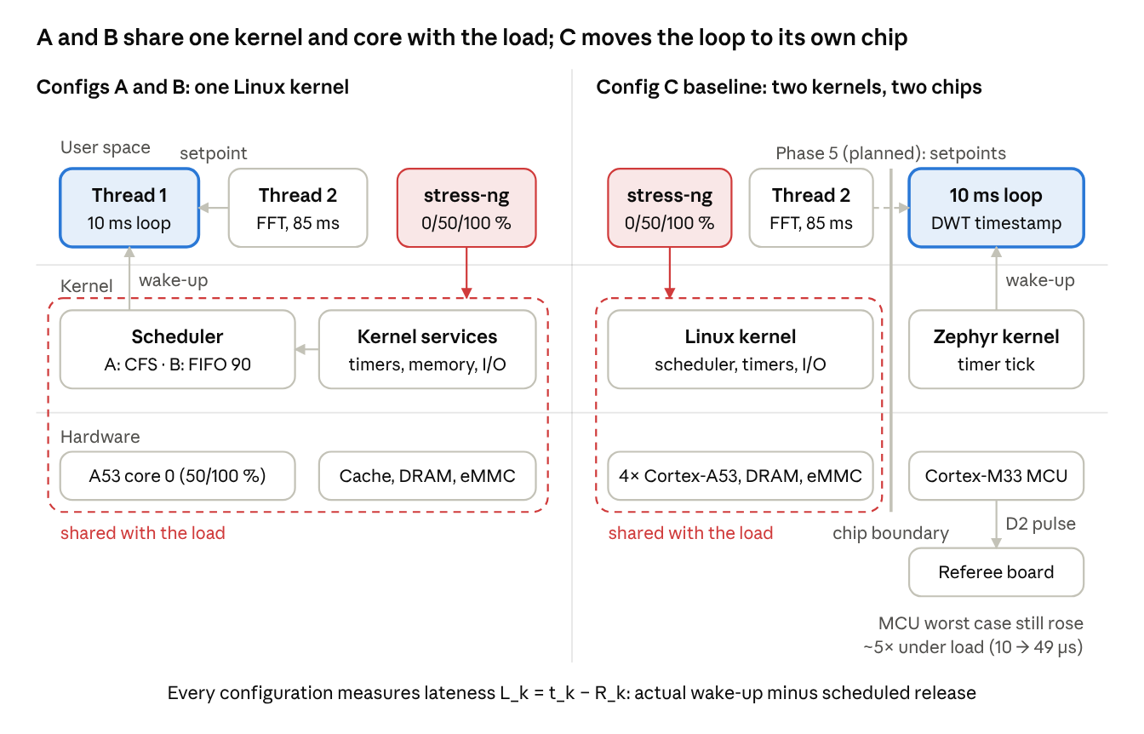
Experiment architecture: Configs A/B vs Config C baseline
In A and B the stress load shares the scheduler, the CPU core and memory with the control loop. In C it stays on the Linux chip; only the planned Phase 5 setpoint link will cross to the MCU.
Each cycle k has an absolute release time R_k = t0 + k × 10 ms, and its lateness is L_k = t_k − R_k. We report jitter (σ_L), the 99.9th percentile, worst-case lateness (WCL) and the deadline miss ratio (DMR: share of cycles with L_k > 1.0 ms, plus a stricter 0.2 ms tier), each at 0, 50 and 100 % stress-ng load.

2. Progress since M1
Phase 2 (Linux setup and Configs A and B) is complete, and the Config C baseline without IPC (task P4.5) is measured on hardware. The Linux→MCU IPC path (Phase 5) is the main open item.
WBS | Work | Status
P2.1–P2.2 | Board access over ADB; Debian 13, kernel 6.16.7 (PREEMPT, not PREEMPT_RT); stress-ng, build tools | Done
P2.1b | Linux↔MCU link identified: Arduino RouterBridge (RPC over the internal serial link) | Done
P2.3 | CWRU dataset: 4 recordings (normal, inner race, ball, outer race), 1024-sample windows, 100 replay frames | Done
P2.4 | Dual-thread C benchmark: 10 ms clock_nanosleep(TIMER_ABSTIME) thread + FFT thread, all timestamps buffered in RAM | Done
P2.5–P2.7 | Configs A and B at 0/50/100 % stress, 10,000 cycles each; Tests 1–5 (I/O, endurance, affinity, mlock, FIFO vs RR) | Done
P2.8 | Analysis pipeline (analyze_latency.py) with unit tests | Done
P4.5 | Config C baseline: MCU loop with DWT cycle-counter timestamps, cross-checked by a second UNO Q timing pin D2; 10,000 cycles × 3 stress tiers | Done (no IPC)
P4.3 | Zephyr k_timer firmware for the 10 ms tick | Drafted, not yet on the board
P3 | 1D-CNN fault classifier | Made optional (see §5)

3. Preliminary results
Worst-case lateness reaches 6.12 ms for CFS, stays under 0.87 ms for SCHED_FIFO, and stays under 0.05 ms for the MCU loop. All 9 runs completed 10,000 cycles (100 s) without a crash.
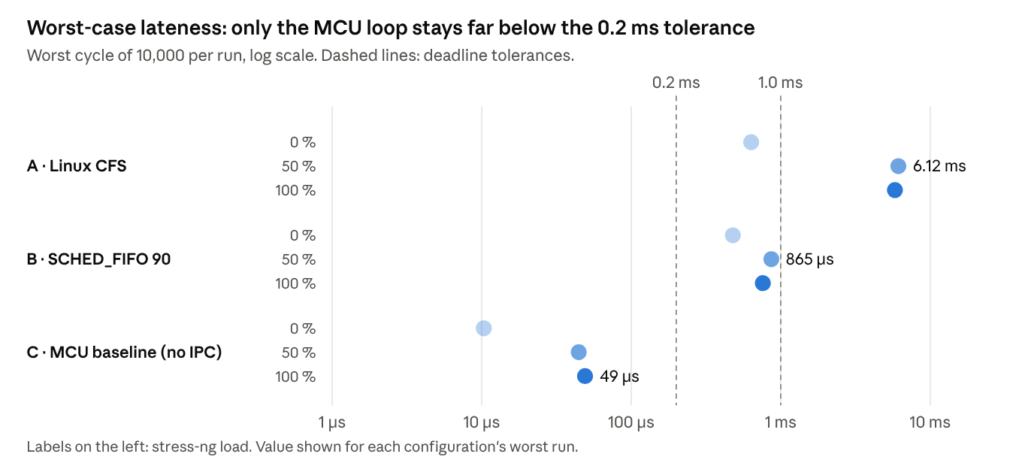
results/summary.md · 10,000 cycles per run, Arduino UNO Q, October 2026
Config | Stress | Jitter σ_L (µs) | p99.9 (µs) | DMR @ 1.0 ms | DMR @ 0.2 ms
A · CFS | 0 % | 30.4 | 400.9 | 0.00 % | 96.93 %
A · CFS | 50 % | 482.1 | 4,178.5 | 2.76 % | 6.83 %
A · CFS | 100 % | 1,041.0 | 4,699.5 | 13.91 % | 18.46 %
B · FIFO 90 | 0 % | 34.0 | 316.0 | 0.00 % | 1.94 %
B · FIFO 90 | 50 % | 38.4 | 412.7 | 0.00 % | 1.55 %
B · FIFO 90 | 100 % | 39.0 | 366.0 | 0.00 % | 1.73 %
C · MCU baseline | 0 % | 2.6 | 10.3 | 0.00 % | 0.00 %
C · MCU baseline | 50 % | 12.2 | 44.4 | 0.00 % | 0.00 %
C · MCU baseline | 100 % | 13.4 | 49.0 | 0.00 % | 0.00 %
Config A's mean lateness at idle is 223 µs, so 97 % of its idle cycles miss the 0.2 ms tier even without load. Linux lateness is measured against CLOCK_MONOTONIC; MCU lateness is measured with the DWT cycle counter after fitting the period.

4. Key findings and limitations
Only the MCU loop meets a 0.2 ms tolerance under load; SCHED_FIFO meets 1.0 ms but not 0.2 ms.
- CFS (A) breaks down under load. DMR at 1.0 ms rises from 0 to 2.76 to 13.91 %, and WCL reaches 6.12 ms. This partly confirms our hypothesis: misses appear, but WCL stayed below the predicted 10 ms.
- SCHED_FIFO (B) keeps WCL under 0.9 ms with no misses at 1.0 ms. Yet 1.6–1.9 % of cycles miss 0.2 ms at every load, even idle. The likely cause is non-preemptible sections in the stock PREEMPT kernel; we have not traced it yet.
- The MCU loop (C baseline) stays under 50 µs, with no misses at 1.0, 0.2 or 0.05 ms. Linux stress still raised its WCL about 5× (10 → 49 µs), so isolation is strong but not total.
- Zephyr's clock drifts against the CPU cycle counter. Our diagnostics show it losing about 19 ppm while busy and 508 ppm while asleep, so the loop really ran at 10.0055 ms per cycle. Jitter and WCL are computed after fitting the period and are unaffected. About half of the 545 ppm offset is still unexplained.
Limitations: one run per condition, so p99.9 rests on about 10 samples. At 0 % stress the Linux threads float across cores; at 50 and 100 % they are pinned to core 0 (Test 3 isolates this). Context-switch and page-fault counts are process-wide, not per thread. Config C does not yet exercise IPC.

5. Changes to the plan and next steps
Changes since M1
- 1D-CNN made optional. The FFT on real CWRU frames already provides the analytics load, and the project evaluates OS behaviour, not model accuracy.
- Milestones moved one week: M2 Oct 27, 2026, M3 Nov 17, 2026, final report (M4) Jan 5, 2027.
- Stress levels finalised. 50 %: 1 CPU worker on core 0, 1 disk and 1 memory worker (25 % of RAM). 100 %: 2 CPU and 2 cache workers on core 0, 1 disk and 1 memory worker (50 % of RAM).
Next steps
- Choose the MCU timing design (the current micros() loop or a Zephyr k_timer) after testing k_timer for the same clock drift.
- Send "latest-value-wins" setpoints over RouterBridge at the ~85 ms analytics cadence; timestamp with the DWT counter and log only after the run.
- Re-run Config C with IPC at 0/50/100 % stress, 10,000 cycles each, and compare it with the baseline.
- Explain the remaining ~250 ppm clock offset; add repeated runs and SoC temperature logging.

